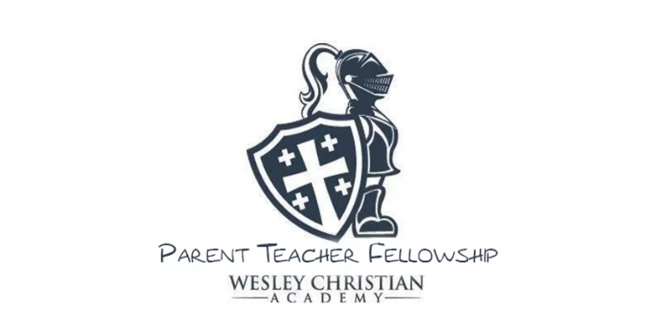
“For we walk by faith, not by sight.” 2 Corinthians 5:7
Walking with Jesus

Minutes
October 5, 2022

Attendees:
Renet McCall, President
Sarah Jo Layland, Vice President
Beverly Taunton, Missions
Margaret Fitzpatrick, Communications & Marketing
Debbie Smith
Cara Martin
Becky Myers
1. Welcome and Prayer, Sarah Jo Layland
Late start due to relocation of meeting, late arrivals and introductions all around. We will need
to be timelier with future meetings. (Begin at 3:45 and end at 4:15)

2. Monthly Mission
a. September: International Dot Day raised $255.50
b. October: Cancer Awareness. Wear pink or other cancer color on October 24 & 25. Funds will be given to Greater Clermont Cancer Foundation. At Sunday’s presentation their representative stated that all funds remain local.

3. Spirit Night Fundraisers
a. September 6-13, Penny Wars: We raised $1200 for Vision/Playground Fund. Next year we would like to have different rules and regular banking deposits to make it easier for students and volunteers. Bank will waive fee if deposits are made daily. Daily total and leaders need to be advertised on Parent Square.
b. September 20th, Texas Roadhouse Spirit Night: Check is pending. Ms. Bristo informed us that we earned $100. Several attendees stated that they thought the amount was low and perhaps not all receipts were designated WCA. Concerns shared with Ms. Bristo after meeting.
c. October 18th, Corelli’s Spirit Night.
d. The idea of two dry erase yard signs or sandwich boards (one for preschool carline and one for school age carline). Ms. McCall to check with Link Printing.
e. Discussed PTF messaging on Parent Square. Ms. Fitzpatrick to check with Ms. Bristo and post Spirit Night Events.

4. Events
a. AR/WIG Party: No volunteers needed. School has arranged a Kona Ice Party.
b. October 13 & 14th, Boosterthon. All donate$30,000 goal. All donations to benefit Vision/Playground Fund. Daily prize distribution volunteers and dance party volunteers’ sign-ups will be posted on Parent Square. First day total was $10,000, which was a little less than last year.
c. October 27th, Fall Festival: Teachers will be handling this event themselves.
d. Proposed events:
Talent show/coffee bar event was not discussed.
Gala/Red Carpet event in replacement of Golf Tournament for following school year was well received. Invitation to church members also.
Spring Golf Tournament sponsors will be requested before years end.

5. Committees:
a. Hospitality: Mr. Rich would be helpful finding backdrops and other decorations for Thanksgiving and Christmas events. Still need to find our what the Preschool and School’s needs are for decoration and photo booths. Ms. Fitzpatrick to check with two others (Ms. Amber and Ms. Julia) about new photobooth decorations.
b. Prayers:
c. Teacher Appreciation: A monthly snack/treat cart discussed. Ms. Fitzpatrick and Ms. Layland take care of shopping. Ms. Layland to confirm number of staff. Discussed changing the treats each month.

6. Other:
We discussed adding local business and student recognition ads in the back of yearbook. Ms. McCall to check with Ms. Bristo about cost per page and approval from Mr. McCue. We discussed that all commercial ads should “be inline with our Christian values and beliefs”. We also discussed asking the students to create a “Walking with Jesus” art page for the yearbook.

Crossing sign and flashing light for Agape House students. We discussed checking with church about this $3000 budgeted item.

Discussed ways to bridge the gap between preschool, school and church. Singing at 9:30 service?

Operation Christmas Child Shoeboxes: We discussed giving one shoebox for each classroom. Ms. Fitzpatrick has enough extra.

Principal Appreciation Month: Ms. McCall to get copies of Mr. McCue and Ms. Bernoska’s “favorites list”, purchase and distribute gifts on Friday, October 28th.

Secretary/Treasurer PTF Board Position: Ms. Myers has volunteered to be Secretary.

6. Next Meeting: November 2, 2022, 2:30, following carline pickup.

